To: | Council
Date: | 27 November 2023
Report of: | Councillor Mark Lygo, Cabinet Member for Safer Communities
Title of Report: | Oxford Safer Communities Partnership (OSCP) Annual Update 2022-23

Summary and recommendations
Purpose of report: | Provide a summary of OSCP’s achievements in 2022-23
Key decision: | No
Cabinet Member with responsibility: | Cllr Mark Lygo, Cabinet Member for Safer Communities
Corporate Priority: | Strong and Active Communities.
Policy Framework:
Recommendation(s): Note the report

Appendices: None

Introduction and background
- Oxford Safer Communities Partnership (OSCP) is Oxford’s statutory partnership to address local community safety priorities in the city. It is responsible for plans to reduce the fear of crime, minimise the likelihood of becoming a victim of crime and address community safety concerns to improve the lives of our residents, businesses and visitors.
- Oxford City Council chair and facilitate the partnership which meets on a quarterly basis to review the priority plans and identify emerging risks within the city.
- OSCP Partnership Board is made up of representatives from:
  - Oxford Local Police Area
  - Oxfordshire County Council’s Youth Justice and Exploitation Service, Fire & Rescue Service, Trading Standards, and Child and Adult Social Care Services
  - National Probation Service
  - Oxford University Hospitals NHS Foundation Trust,
  - Oxfordshire Clinical Commissioning Group,
  - Office of the Police and Crime Commissioner,
  - Oxford Brookes University
  - University of Oxford
  - Turning Point
OSCP achievements 2022-23
- Each financial year OSCP agrees a set of annual priorities based on a Strategic Intelligence Assessment (SIA) of crime and disorder in the city. The SIA, and an interactive crime dashboard can be found on the Oxfordshire Insight website:
- https://insight.oxfordshire.gov.uk/cms/system/files/documents/OxonSIA2023_FINAL.pdf
- To view crime types by neighbourhood, an interactive map is included within the Oxfordshire Insight website.
https://public.tableau.com/views/OxfordshireCrimeDashboard/Explorelocal?embed=y%3Adisplay_count&%3AshowVizHome=no%20#2
- The following section provides an overview of some of the work the partnership undertook in 2022-23.
Tackling alcohol-related disorder - NightSafe
- Continuing the successful launch of the Safer Streets project in 2022, the NightSafe Oxford Programme continued to address alcohol-related violence and anti-social behaviour within the night-time economy, with a particular focus on reducing the risk of harm to women and girls.
- The collaborative approach includes the Police, Oxfordshire County Council, Oxford City Council, Oxford University, Oxford Brookes University, voluntary groups such as the Street Pastors and Oxford City Angels, and venues operating in the night-time economy.
- Each weekend the police brief partners on the number of police officers for the evening and any intelligence the police wish to raise. This could be large events occurring on the night, unwanted groups gathering in the city centre or East Oxford and any persons the police are seeking.
- During 2022-23, the police undertook Project Vigilant which targets known offenders of sexual violence within the night-time economy.
- Thames Valley Police operate the CCTV system on behalf of Oxford City Council. Oxford has public spaces CCTV in the city centre (44), East Oxford, Barton, Temple Cowley, Wood Farm and Blackbird Leys. Partners have a 2-way radio and can provide information back to the police via the CCTV suite (Brava Victor)
- In 2021, 25 cameras were upgraded by the Council within the city centre. A further three cameras were upgraded in 2022. The upgrade of cameras across Oxford will continue in 2023.
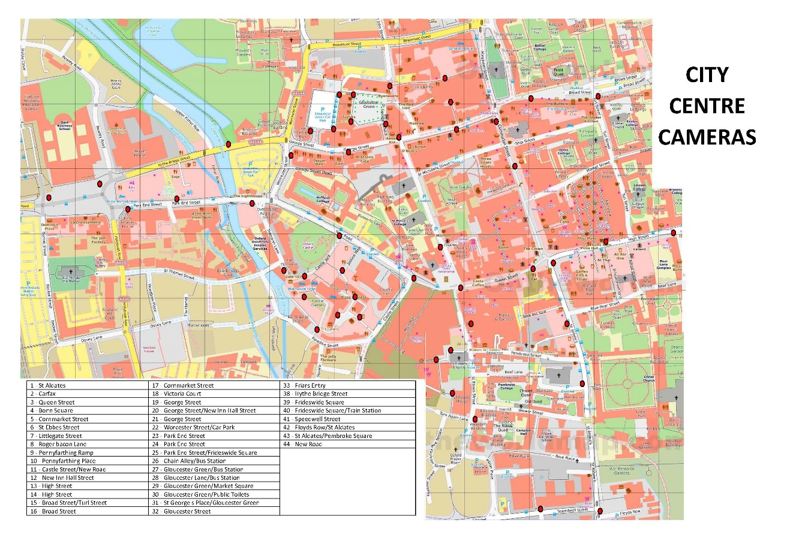
- Street Pastors and Oxford City Angels are both voluntary organisations and patrol the city centre on Friday or Saturday nights, with the City Angels also patrolling East Oxford.
- The Safe Places network is an important element of the NightSafe Programme. There are several businesses within the city centre and Cowley Road that provide sanctuary for those people that feel vulnerable or unsafe.
- Licensing Authorities alcohol and late-night entertainment policies ensure all premises implement safety approaches through their licensing conditions. To support the Safe Places approach, some of the conditions for licensing include Ask Angela-style reporting processes, CCTV and door staff training.
Tackling Serious Violence
- Following on from a serious violent incident and increases in anti-social behaviour in an Oxford neighbourhood, an OSCP multi-agency project was set-up in collaboration with the local community.
- The Project Team used a Prepare, Prevent, Protect, Pursue framework approach to coordinate its multi-agency response, with each section having immediate and legacy activities in order to sustain interventions. Each element had a lead officer with the Pursue strand led by a police officer.
- The Prepare strand was led by the Council’s Community Safety Problem Solving Officer, who gathered community views by using a web-based consultation portal. There were 436 visitors to the site and 65 people completing the survey. A map of the area allowed residents to pinpoint where they felt safe or unsafe, and why. This information was added to the local crime trend analysis in order to identify areas suitable for crime prevention that included CCTV, improved lighting and longer term redesigns.
- Those suspected of being involved in the violence and exploitation of vulnerable people were identified and their behaviour dealt with. Young people were engaged with and a series of youth activities developed for the area.
- The legacy activities included on-going partnership assessment of risk and harm in the locality, and partnership structures developed to support disruption activities when needed.
- In early 2023 the project won Thames Valley Police’s Laycock Award.
- This approach will be rolled out to other parts of the city and has been developed into a proposal for a county-wide place-based response to serious violence, exploitation and ASB.
Human Trafficking and Exploitation
- Oxfordshire’s Anti-Slavery Coordinator has continued to develop the multi-agency Guidance and Pathways document for those agencies that work in this sector. Involving over 40 agencies, these new processes have resulted in more than 50 Anti-Slavery Multi-Agency Risk Assessment Conferences (ASMARAC) and 17 Anti-Slavery Multi-Agency Response Team meetings to disrupted those involved in modern slavery and exploitation. 26 multi-agency disruption plans were implemented involving 17 partner agencies.
- Reports of exploitation most concerned brothels and sex working, taking over a vulnerable person’s residence and cannabis cultivation. There are slightly more male victims than females, with most victims in the 25-34 age group, closely by those aged 18-24 and 35-44.
- Thirty people in Oxford City have been supported through a multi-agency approach to free them from their exploiters. Three were supported to secure housing in other areas for their safety and one obtained safe accommodation through the National Referral Mechanism (NRM).
Domestic Abuse
- Oxford City Council’s Domestic Abuse lead officer worked with colleagues across Oxfordshire to implement the Oxfordshire Domestic Abuse Strategy and the Oxfordshire Safe Accommodation Strategy action plans. This resulted in the procurement of a new Oxfordshire Domestic Abuse Service and the Independent Domestic Violence Advisory (IDVA) Service, the main providers of services for domestic abuse survivors in Oxfordshire.
- Oxford City Council provides a Sanctuary Scheme for survivors of domestic abuse who wish to stay in their properties in Oxford. This scheme included providing support and enhanced security measures. In 2022-23, 76 survivors and their families were kept safe in their home.
- Oxford City Council employed two Domestic Abuse Housing Link (DAHLs) Workers to support clients with additional needs and complex housing issues where domestic abuse is a factor. The DAHLs also support staff to improve their response to survivors of domestic abuse, identifying gaps in provision and learning to improve processes and outcomes.
- The Council is also working towards the Domestic Abuse Housing Alliance (DAHA) accreditation. The accreditation embeds domestic abuse responses across the whole Council to improve outcomes for survivors.
- OSCP has the responsibility to commission Domestic Homicide Reviews (DHR). In 2022, a DHR was signed off by the Home Office and the action plan has been completed.
Anti-social Behaviour (ASB)
- Oxford City Council has two teams that tackle the various forms of anti-social behaviour within the city. For the year 2022 there were 2,616 cases logged.

- In 2022, the Community Response Team dealt with 2,236 cases. The following charts provide a breakdown of case type. The majority of cases related domestic or commercial noise. Drill down those case types highlights parties and people noise as being the main complaint.

- The Anti-Social Behaviour Investigation Team (ASBIT) investigated 380 cases. Their work is involves multiple partners including the police, social services, housing providers, health workers including GP surgeries. Work includes:
  - Threats of violence and intimidation
  - Harassment
  - Safeguarding concerns
  - Domestic abuse
  - Substance misuse

OSCP Priorities for 2023-24
- At an OSCP Partnership Board meeting, held on 31st May 2023, the Board agreed the priorities for 2023-24. These priorities take into account the overview of crime trends affecting Oxford. The priorities for 2022-23 are:
- Delivering neighbourhood crime priorities such as drug misuse and dealing, anti-social behaviour and alcohol-related violence through the partnership’s Neighbourhood Problem-Solving Framework.
- Continue to use our Common Place consultation process to engage with our communities to understand their community safety concerns and develop responses.
- Support the police to deliver their hate crime action plan.
- Work with partners in Oxfordshire to evaluate the feasibility of an Oxfordshire CCTV Hub.
- Support the implementation of the Prevent Duty and Martyn’s Law to protect our communities from the risk posed by extremist activities.
- Reduce the level of cycle crime in the city.
- Develop the Interact web-based crime dashboard to better understand local community safety trends and evaluate interventions.
- Reduce serious violence and exploitation by:
  - Implementing Oxfordshire’s Modern Slavery Delivery Plan, led by the Oxfordshire Anti-Slavery Coordinator.
  - Working in partnership with the Thames Valley Violence Reduction Unit and local partners across Oxfordshire to deliver the Serious Violence Duty.
  - Continue to work with statutory partners across Oxfordshire to tackle child exploitation.
- To support the Government’s Violence against Women and Girls Strategy by:
  - Delivering the NightSafe 2023 programme in partnership with the Oxford NightSafe Network.
  - Continuing to tackle domestic abuse by attainment Domestic Abuse Housing Accreditation (DAHA) in Oxford City Council and support the Oxfordshire Domestic Abuse Strategy Group.
  - Commissioning domestic homicide reviews in Oxford.
  - Supporting Thames Valley Police’s VAWG Strategy.

Report author | Richard Adams
Job title | Community Safety Service Manager
Service area or department | Community Service
Telephone | 01865 252283
e-mail | rjadams@oxford.gov.uk

Background Papers: None

